GRADUATION PROJECT REPORT

Security Information and Event Management
SIEM Implementation Using Wazuh on VMware

Integrated Network Security Monitoring System

Combining Wazuh SIEM with Router & Firewall Log Collection via Syslog and PNETLab Network Simulation

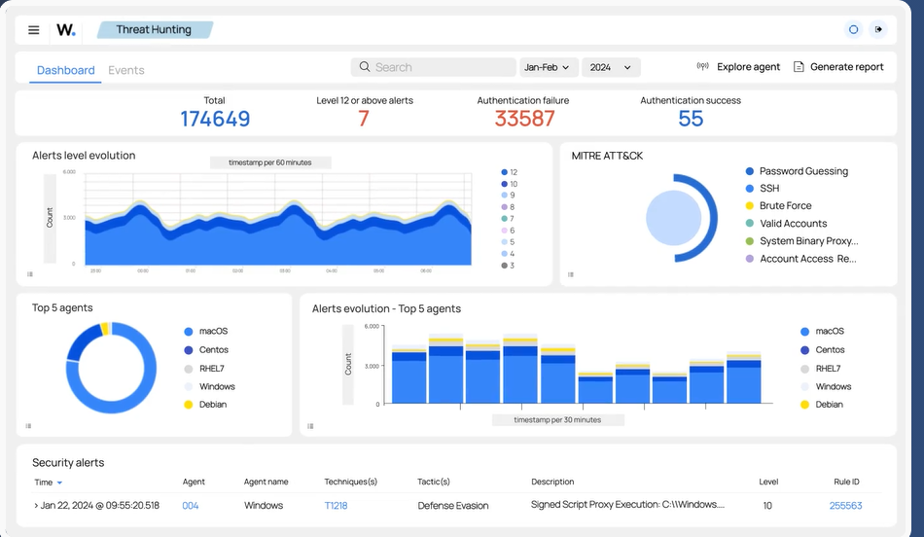

1. What is SIEM? — Concept & Importance

1.1 Definition
Security Information and Event Management (SIEM) is a comprehensive cybersecurity solution that combines two core disciplines: Security Information Management (SIM) and Security Event Management (SEM). SIEM platforms collect, aggregate, normalize, and analyze log data from across an organization's entire IT infrastructure in real time, providing security teams with centralized visibility and the ability to detect, investigate, and respond to threats.

The term SIEM was first coined by Gartner analysts Mark Nicolett and Amrit Williams in 2005. Since then, SIEM has evolved from basic log management tools into sophisticated platforms that incorporate machine learning, behavioral analytics, and threat intelligence integration.

1.2 Core Functions of a SIEM
- Log Collection & Aggregation: Ingests raw logs from servers, endpoints, firewalls, routers, applications, and cloud services into a central repository.
- Normalization: Converts heterogeneous log formats (Syslog, Windows Event Log, CEF, LEEF) into a unified schema for consistent analysis.
- Correlation & Detection: Applies rule-based and behavioral logic to identify patterns that indicate security incidents across multiple data sources.
- Alerting & Notification: Generates real-time alerts when suspicious activities match defined detection rules.
- Threat Intelligence Integration: Enriches events with external threat feeds (IP reputation, IOC databases) for contextual awareness.
- Incident Management & Forensics: Provides investigation tools, case management, and forensic timelines for post-incident analysis.
- Compliance Reporting: Automates generation of compliance reports for standards like PCI-DSS, ISO 27001, HIPAA, and NIST.

1.4 SIEM Architecture Overview
A SIEM system is composed of several interconnected layers, each responsible for a distinct phase of the data pipeline:

- Data Collection Layer: Agents, Syslog collectors, API integrations pull data from all sources.
- Parsing & Normalization Layer: Decoders transform raw log text into structured fields (source IP, destination, action, timestamp).
- Storage Layer: Normalized events stored in a scalable data store (Elasticsearch/OpenSearch in modern SIEMs).
- Correlation Engine: Rules and ML models analyze stored and streaming events to detect anomalies.
- Dashboard & Visualization: Security analysts interact with data through dashboards, search queries, and reports.
- Response Layer: Automated playbooks or manual analyst actions to contain, eradicate, and recover from incidents.

2.2 Wazuh Core Components
Component | Role | Location
Wazuh Manager | Central brain — processes events, applies rules, generates alerts | Server
Wazuh Indexer | Based on OpenSearch — stores and indexes all security events | Server
Wazuh Dashboard | OpenSearch Dashboards UI — visualization, search, case management | Server
Wazuh Agent | Lightweight process on monitored endpoints sending data to manager | Each endpoint
Syslog Listener | Agentless log collection — receives UDP/TCP Syslog from network devices | Manager

2.3 Wazuh Capabilities Relevant to This Project
- Syslog Collection: Wazuh Manager listens on UDP/TCP port 514 to receive Syslog messages from routers and firewalls — no agent needed on network devices.
- Custom Decoders: Parses proprietary log formats from Cisco IOS, MikroTik, pfSense, Fortinet, and other vendors using regex-based decoders.
- Custom Rules: 3,000+ built-in rules covering network threats (port scans, brute force, firewall drops) that trigger alerts automatically.
- Active Response: Can automatically block malicious IPs, quarantine endpoints, or run scripts in response to detected threats.
- CIS Benchmarks: Built-in compliance checks for routers and firewalls against industry security baselines.
- Threat Intelligence: Integration with VirusTotal, MISP, and AbuseIPDB for IP and file reputation enrichment.

3. Connecting Routers & Firewalls to Wazuh

3.1 The Syslog Protocol
Syslog is the industry-standard protocol for transmitting log messages across IP networks, defined in RFC 5424. Network devices such as routers and firewalls — which cannot run software agents — use Syslog to forward their event logs to a central collector. Wazuh Manager includes a built-in Syslog listener that acts as the receiving endpoint.

Syslog messages carry a severity level (Emergency, Alert, Critical, Error, Warning, Notice, Informational, Debug) and a facility code (Kernel, User, Mail, Daemon, etc.) encoded together as a Priority value. Understanding these is essential for writing effective Wazuh detection rules.

3.2 Wazuh Syslog Configuration
To enable agentless log reception on the Wazuh Manager, the following block is added to the ossec.conf configuration file located at /var/ossec/etc/ossec.conf:

<remote>
<connection>syslog</connection>
<port>514</port>
<protocol>udp</protocol>
<allowed-ips>192.168.1.0/24</allowed-ips>
</remote>

3.3 Router Configuration by Vendor

Cisco IOS Router
On a Cisco IOS router, Syslog forwarding is configured from the CLI:

Router# configure terminal
Router(config)# logging on
Router(config)# logging host 192.168.1.10
Router(config)# logging trap informational
Router(config)# logging source-interface GigabitEthernet0/0
Router(config)# service timestamps log datetime msec

Where 192.168.1.10 is the IP address of the Wazuh Manager server. The 'logging trap informational' command forwards all messages at severity level 6 (Informational) and above.

In pfSense, navigate to Status > System Logs > Settings. Enable Remote Logging, enter the Wazuh Manager IP as the Remote Syslog Server, select UDP port 514, and check the log categories you want forwarded (Firewall Events, DHCP, Authentication).

3.4 How Wazuh Processes Network Device Logs
Once Syslog messages arrive at the Wazuh Manager, they pass through a three-stage processing pipeline:

- Decoder Stage: The decoder engine parses each raw log line using regex patterns defined in /var/ossec/etc/decoders/ and /var/ossec/ruleset/decoders/. It extracts fields such as source IP, destination IP, protocol, port, and action (permit/deny).
- Rule Matching Stage: The extracted fields are evaluated against rules in /var/ossec/ruleset/rules/. Rules have a severity level (1-15) and can reference other rules for multi-stage correlation (e.g., 10 failed logins followed by a success = brute force).
- Alert Generation Stage: When a rule fires, Wazuh generates an alert containing the original log, decoded fields, rule metadata, and a MITRE ATT&CK mapping, then indexes it into OpenSearch.

Wazuh Installation on VMware

4.1 Prerequisites & Lab Requirements
Resource | Minimum | Recommended for Project
Host OS | Windows 10/11 or Linux | Windows 11 with VMware Workstation Pro 17
RAM (total) | 12 GB | 16–32 GB
CPU | 4 cores | 8 cores (Intel VT-x/AMD-V enabled)
Disk Space | 80 GB free | 120+ GB (SSD strongly preferred)
VMware Version | Workstation Pro 16+ | Workstation Pro 17 / ESXi 7+
Wazuh Version | 4.x | 4.9.x (latest stable)
Guest OS | Ubuntu 20.04 LTS | Ubuntu 22.04 LTS (recommended)

4.2 Step 1 — Create the Wazuh Server VM in VMware
- Open VMware Workstation. Click File > New Virtual Machine > Custom (Advanced).
- Select hardware compatibility: Workstation 17.x. Click Next.
- Choose 'Installer disc image file (iso)' and browse to your Ubuntu 22.04 Server ISO.
- Set Guest OS: Linux > Ubuntu 64-bit. Name the VM 'Wazuh-SIEM'.
- Assign processors: 2 processors, 2 cores each (total 4 vCPUs).
- Assign RAM: 8192 MB (8 GB). For production-grade testing use 16384 MB.
- Network: Select 'Use bridged networking' so the VM gets a real IP on your lab network, or use Host-Only for isolated testing.
- Create a new virtual disk: SCSI, 60 GB, store as single file. Click Finish.

4.3 Step 2 — Install Ubuntu Server on the VM
- Power on the VM. Ubuntu installer will launch automatically from ISO.
- Choose language, keyboard layout, and proceed with default settings.
- When prompted for network interface, note the assigned IP address — this is your Wazuh Manager IP.
- Select 'Ubuntu Server (minimized)' installation option.
- Create a user account. Enable OpenSSH server when prompted.
- Complete installation and reboot. Remove ISO from virtual drive if prompted.

4.4 Step 3 — Install Wazuh Using the Quick-Install Script
Wazuh provides an official all-in-one installation assistant that installs the Manager, Indexer, and Dashboard in a single command. This is the recommended approach for lab environments:

# Update the system first
sudo apt-get update && sudo apt-get upgrade -y

# Download and run the Wazuh installation assistant
curl -sO https://packages.wazuh.com/4.9/wazuh-install.sh
curl -sO https://packages.wazuh.com/4.9/config.yml

# Edit config.yml — replace 'indexer-1' IP with your VM IP
nano config.yml

# Run the installer (all-in-one: manager + indexer + dashboard)
sudo bash wazuh-install.sh -a

# Installation takes 10–20 minutes. Save the admin credentials!

4.5 Step 4 — Verify Services Are Running
sudo systemctl status wazuh-manager
sudo systemctl status wazuh-indexer
sudo systemctl status wazuh-dashboard

All three services should show 'active (running)' in green. Access the Wazuh Dashboard by opening a browser and navigating to https://<WazuhVM-IP> — accept the self-signed certificate warning, then log in with the admin credentials saved during installation.

5. Network Integration & PNETLab Connectivity

5.1 Understanding the Lab Topology
This project uses a dual-platform lab architecture: Wazuh SIEM runs as a VMware VM on the physical host, while the network infrastructure (routers, switches, firewalls) runs inside PNETLab — an advanced network emulation platform based on EVE-NG. The critical challenge is enabling PNETLab's virtual network devices to communicate with the VMware VM across the hypervisor boundary.

5.3 Network Connectivity Architecture
For PNETLab's emulated devices to send Syslog messages to Wazuh, both the PNETLab VM and the Wazuh VM must share a common VMware virtual network. The recommended approach uses VMware's Host-Only Network (VMnet1) or a custom VMnet as a shared bridge:

- In VMware, go to Edit > Virtual Network Editor. Create a new network VMnet2 (or use VMnet1) as Host-Only, and assign subnet 192.168.100.0/24.
- Attach the Wazuh Server VM to VMnet2 by editing its VM settings > Network Adapter > Custom: VMnet2. Assign static IP 192.168.100.10/24 on this interface.
- Attach the PNETLab VM to the same VMnet2 by adding a second network adapter (also VMnet2). Assign PNETLab's management interface 192.168.100.20/24.
- Inside PNETLab, configure a Management Cloud (Cloud0) that bridges to the PNETLab VM's eth1 (the VMnet2 interface). This allows PNETLab nodes to reach external VMware VMs.
- Connect the Management Cloud node in your PNETLab topology to a router or L3 switch acting as the gateway for all lab devices.
- Configure the gateway router to route traffic between lab subnets and the 192.168.100.0/24 management network where Wazuh lives.

5.4 Configuring PNETLab Devices to Forward Logs to Wazuh
With routing established between PNETLab and Wazuh VM, configure each network device in the topology to send its Syslog output to 192.168.100.10 (the Wazuh Manager IP). Refer to Section 3.3 for vendor-specific commands.

Verify connectivity from inside PNETLab before configuring Syslog forwarding:
# From inside a PNETLab router (Cisco IOS):
Router# ping 192.168.100.10

# On Wazuh VM — verify Syslog messages are arriving:
sudo tcpdump -i any port 514 -n

# Check Wazuh archives for incoming network device logs:
sudo tail -f /var/ossec/logs/archives/archives.log | grep -v agent

5.5 Enabling Syslog Reception in Wazuh Manager
Edit /var/ossec/etc/ossec.conf and add the remote syslog block (shown in Section 3.2). Open UDP port 514 in the firewall on the Wazuh server:
sudo ufw allow 514/udp
sudo ufw allow 514/tcp
sudo ufw allow 443/tcp # Wazuh Dashboard HTTPS
sudo systemctl restart wazuh-manager

6. Verification & Monitoring

6.1 Confirming Log Ingestion in Wazuh Dashboard
- Open a browser and navigate to https://192.168.100.10 (Wazuh Dashboard).
- Log in with admin credentials. Navigate to Home > Explore > Discover.
- In the index pattern selector choose 'wazuh-alerts-*' or 'wazuh-archives-*'.
- Set the time filter to 'Last 15 minutes'. Apply the filter: agent.name:"router-name" or data.srcip exists.
- If logs are arriving, you will see events with decoded fields: data.srcip, data.action, data.protocol, and rule.description.

